**Building of Workflow Package**

1. From RHPAM Workbench, Open the project then navigate to Settings tab.

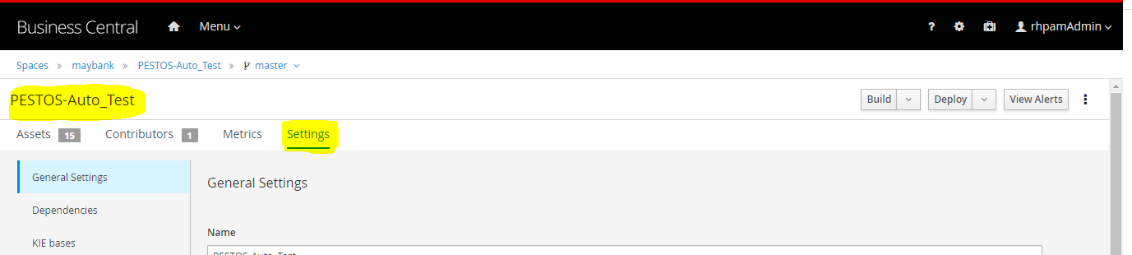

1. Scroll down to the bottom of the page.

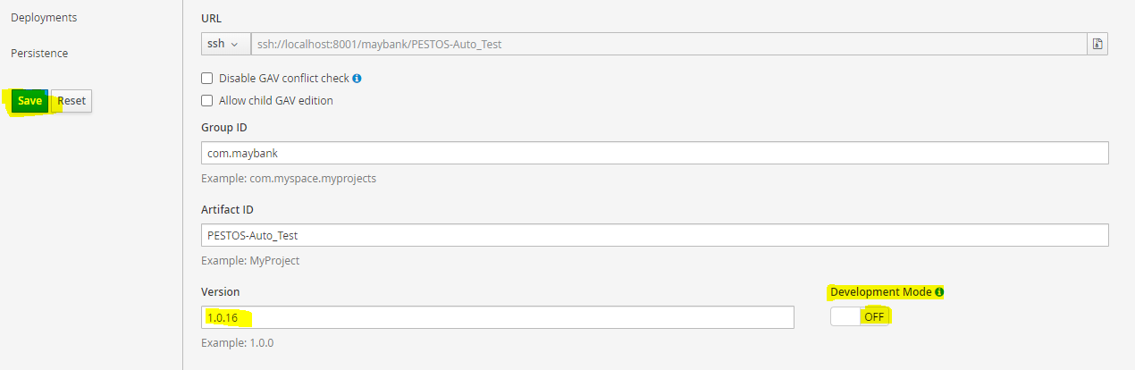

* Toggle to turn OFF the Development Mode switcher.
* Change the version number in Version field.
* Click Save, to save the changes.

1. Go back to the top of the page then click on Build button to build the Project.

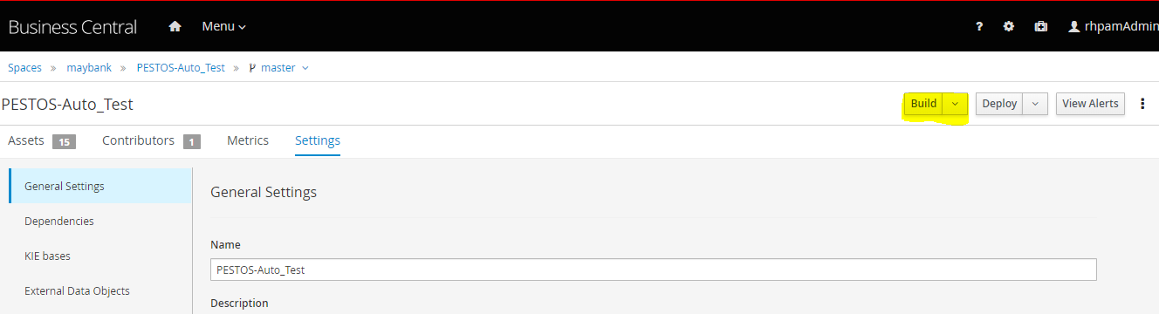

1. A build notification will be shown after successful build.



1. A build package will be created in ../.m2/ directory of the RHPAM Workbench Server

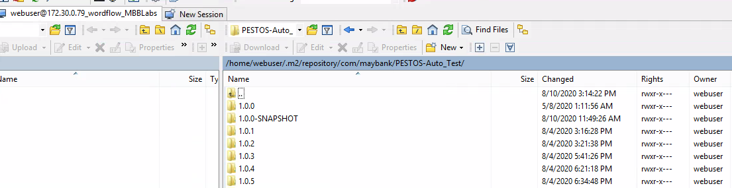

**Deployment of Workflow Project**

1. Copy the entire directory of the Workflow build package (i.e. PESTOS-Auto_Test) to the Processing Server via Winscp.
   1. Path : /home/<USERNAME>/.m2/repository/com/maybank
2. Open Processing Server web services Url.
   1. http://<ProcessingServerIP>:<PORT>/kie-server/docs/#/
3. Find the “Creates a new KIE container in the KIE Server with a specified KIE container ID” section.
4. Click on “Try It Out” button to use the service.
5. Below details can be used as parameters which are needed to passed.
   1. Container Id: Name of the workflow or rules folder which needs to be deployed
   2. Group Id : com.maybank
   3. Artifact Id : Name of the workflow or Rules folder which needs to be deployed
   4. Version : 1.0.0

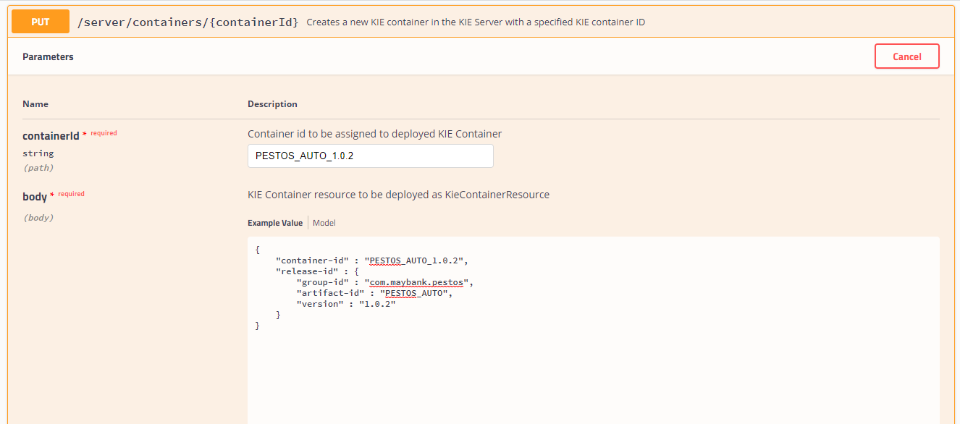

1. Execute the same by pressing the “Execute” button. Sample success response is attached below.

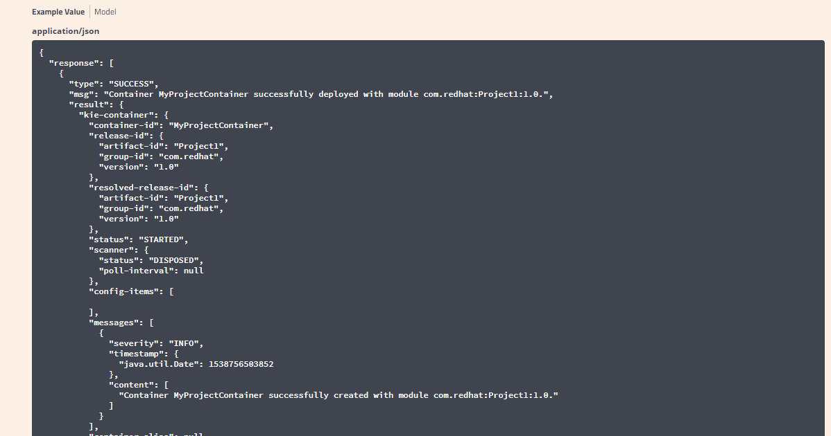

1. Workflow package deployment completed.

* **Workflow Registration to TaskInboxUI**

1. Access the TaskInboxUI URL.

http://<INBOXIP>:<PORTNO>/TaskInboxUI

1. After login, Access the admin module by replacing the “loadBaseData” with “applicationlist”.

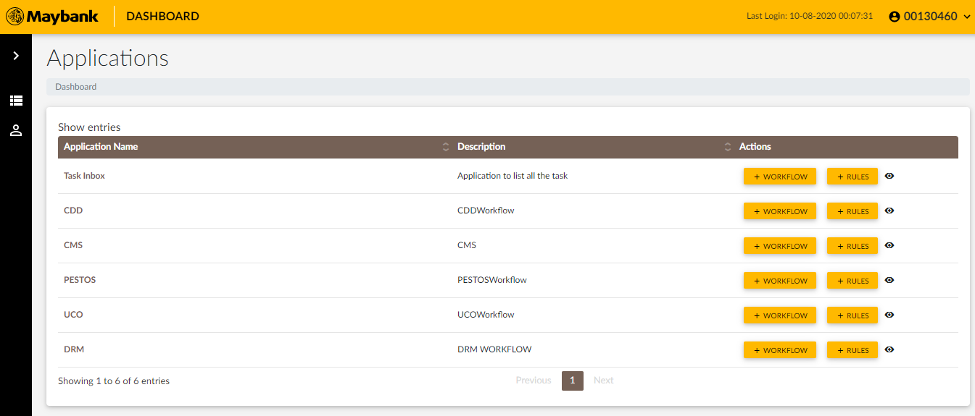

1. Click on the “+ Workflow” button located at the right side of the Application Name . Below screen would appear.

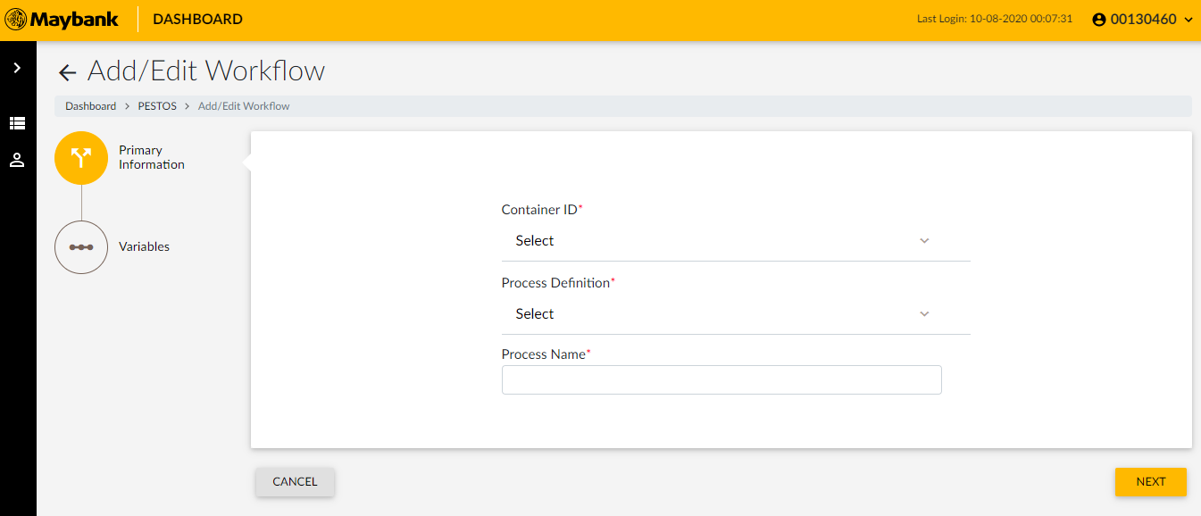

1. Select appropriate details.
   1. Container ID : As registered in the processing server
   2. Process Definition : As per the requirement
   3. Process Name: Names should be given as per teams recommendations as other teams are using these names to call the workflows.

*Process name must be unique.

All the above details must be shared by respective application team along with relevant the Workflow details

1. Press next, in case of below error, please deactivate the already existing workflow against the same container and process definition. Contact application team for advice.

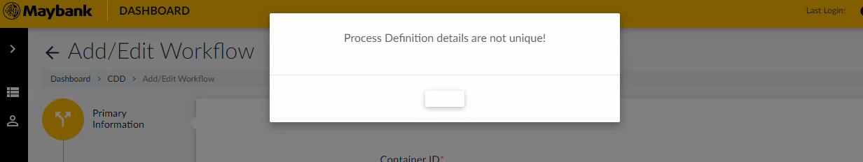

1. Press Next

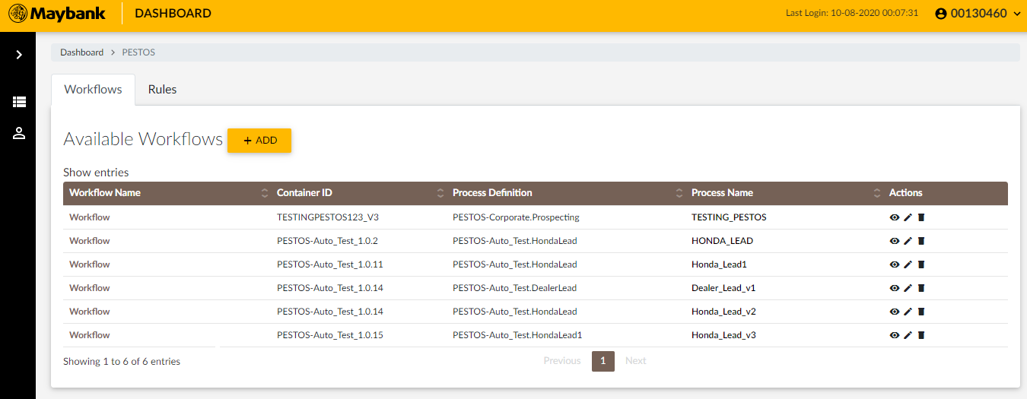

1. Press Edit (pen) icon.

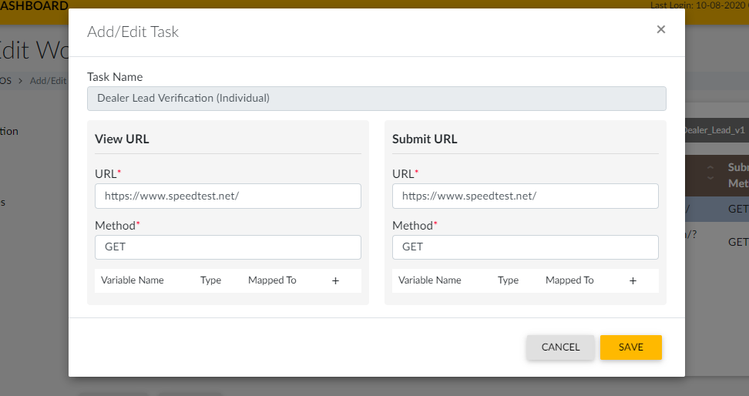

1. Fill out the required details as below.
   1. URL : http://<CDDApplicationIP:<PORTNO>/CDD/applicationRedirect
   2. Method : GET​
   3. Add below variables ( All variables have to be added as strings)

|  |  |  |  |
| --- | --- | --- | --- |
| Variable Name | Type | Mapped To | Value (In case of Constant) |
| ucif | String | UCIF | - |
| action | String | Constant | redirect |
| taskName | String | Constant | Task Name as above in the screen |
| screenUrl | String | Constant | TaskDashboard |
| redirectURL | String | Constant | loadRedirectData |

Above details have to filled in Submit & View sections of each manual tasks.

1. The Page will show the information entered.

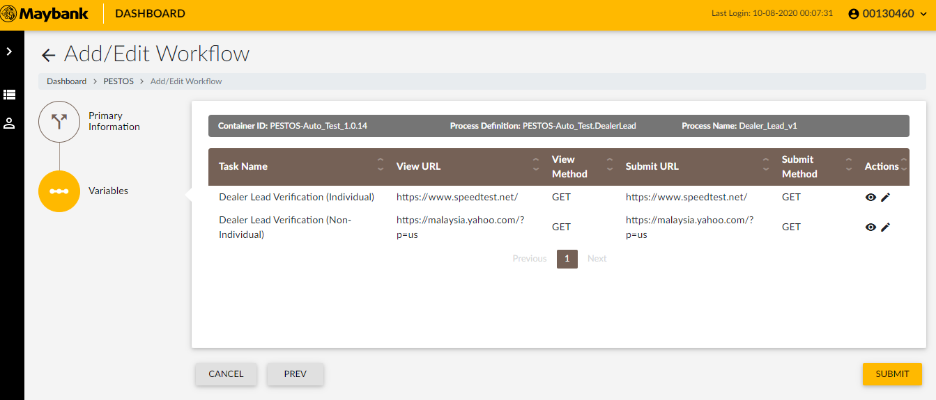

1. Press Submit to complete.